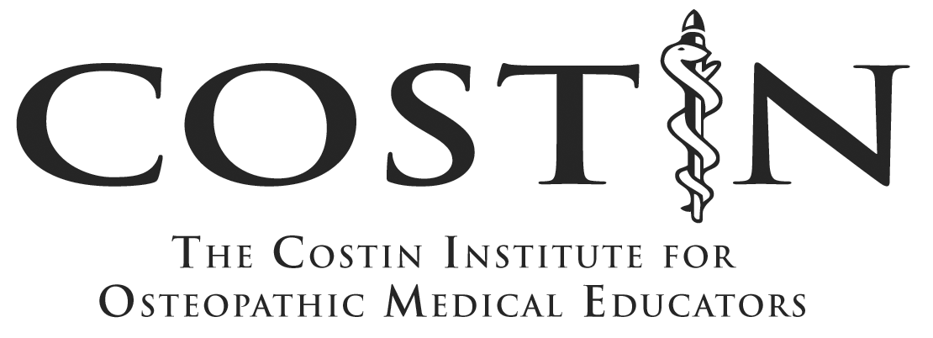

Application for Admission

Cohort 20

Name:
Home Address:

Home Phone:
Business Address:

E-mail:

Preferred Mailing Address: Home Business
Preferred means of contacting you: E-Mail Other _____________
Is there anyone else (i.e. your assistant) who should be included on all correspondence? If so please specify name and email
________________________________________________________________________
Birthdate:
Gender: Male Female Non-Binary
Citizenship: U.S. Other _______________________________

Ethnic Background: African-American/Black Hispanic/Latino

(Optional) Asian/Pacific Islander Native American

Caucasian/White Multi-Racial

Other ___________________

MWU/CCOM Affiliation (please specify):

II. Professional Information:
Please attach a copy of your curriculum vitae.

III. Interest in the Costin Institute
Please answer the following questions. You may attach a separate sheet with your responses.
- Why are you interested in becoming a Costin cohort member?

- What are your goals for the program? What are the skills or topics you are most interested in learning?

- What kind of position in academe do you anticipate securing upon your completion of the Costin program?

- Is there anything else you would like the Admission Committee to know about you?

IV. Letters of Recommendation:
Please submit two letters of recommendation.

The letters should address your commitment and achievements in medical education. Please submit letters to:

Costin Institute
CI Application
CCOM/MWU
555 31st Street
Downers Grove, IL 60515
- or -
E-mail to: costin@midwestern.edu

Application for the Costin Institute

Instruction Sheet
(Keep for your records)
Hand-written applications will not be accepted.

The following items are required for a completed application to the Costin Institute:

- Completed Application form (which includes):
  - Demographic information
  - A copy of your C.V.
  - Answers to the questions listed under “Professional Commitment”
- Two letters of recommendation

Important Dates:

Deadline: TBD

Costin Institute Dates for Cohort 20:

- TBD

Questions: Call: 630-515-6159
E-mail: costin@midwestern.edu
Web: www.costininstitute.org

Hand-written applications will not be accepted.

